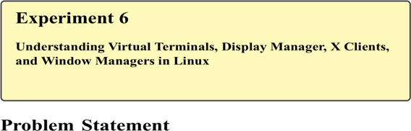
Linux operating systems support multiple user sessions and interfaces through the use of virtual terminals and graphical environments. Understanding how Linux manages textbased terminals, graphical display servers, display managers, X clients, and window managers is essential for system administration, troubleshooting, and cyber security operations.
The problem is to explore and understand virtual terminals, display managers, X clients, and window managers, and to practice switching between text-based and graphical interfaces in a Linux environment.

Theory

Virtual Terminals
Linux supports multiple virtual terminals (VTs) that allow users to access several independent terminal sessions simultaneously. These terminals run in text mode and are useful for system recovery and troubleshooting.
Common key combinations:
- Ctrl + Alt + F1 to Ctrl + Alt + F6 – Text-based virtual terminals
- Ctrl + Alt + F7 (or F1 on some systems) – Graphical interface

Display Manager
A display manager provides the graphical login interface and manages user sessions. It starts the graphical server and handles authentication.
Common display managers:
- GDM (GNOME Display Manager)
- LightDM
- SDDM

X Window System
The X Window System (X11) is responsible for handling graphical display, keyboard, and mouse input. It enables graphical applications (X clients) to run on a Linux system. X Clients
X clients are graphical applications that communicate with the X server to display windows. Examples include:
- Terminal emulator
- Web browser
- Text editor

Window Manager
A window manager controls the placement, appearance, and behavior of windows on the screen.
Examples:
- GNOME Shell
- KDE Plasma
- Xfce
- Openbox

Commands Used
tty | Display current terminal
who | Show logged-in users
w | Show user activity
startx | Start X Window System
systemctl status | Check display manager status
ps | View running processes
echo $DISPLAY | Display X session variable

Procedure
Log in to the Linux system and open the terminal.
Log in to the Linux system.
Open the terminal. Check the current terminal:
tty
Switch to another virtual terminal using:
Ctrl + Alt + F2
Log in and verify terminal access.
Switch back to graphical mode:
Ctrl + Alt + F1 or Ctrl + Alt + F7
Check logged-in users:
who w
Check the display manager status:
systemctl status gdm
(Replace gdm with lightdm or sddm if applicable)
Verify X session variable:
echo $DISPLAY
List running X-related processes:
ps -e | grep X

Sample Execution
$ tty
/dev/pts/0
$ who
student tty2 2025-01-10 09:30

$ echo $DISPLAY
:0
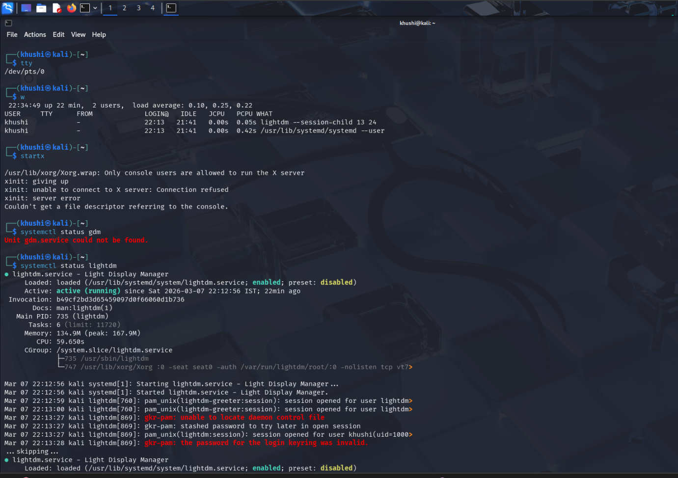
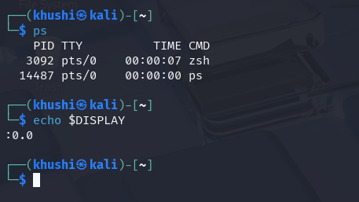

Result
Virtual terminals, display managers, X clients, and window managers were successfully explored. The student gained practical understanding of Linux system interfaces and graphical session management.

